Salary_dataset

- Imported the dataset and perfomed EDA on the dataset, plotted several plots.
- Histogram plot for exp is as follows, it is slightly right skewed.

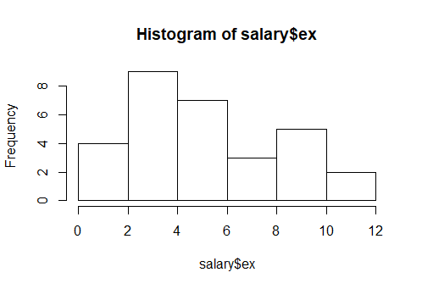
- Extremely strong correlation of 0.97 exits between input and output
- 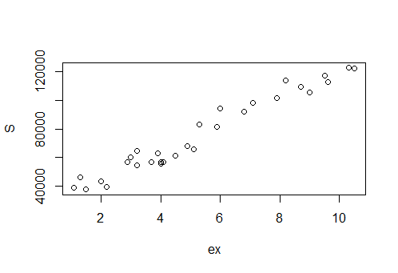
- Then formed several models and found out model_1 is the best one
- model.1- S=25792.2 +9450.0(ex), r=0.9782416, R^2=0.957, rmse=5592.0449(best model)
- for 95% confidence
- lwr- S=21136.061 +8674.119(ex)
- upr- S=30448.34+10225.81(ex)

- model.2- s=14928 + 40582 log(ex), r=0.9240611, R^2=0.8539

- model.3- S=-16056+ 41501 sqrt(ex), r=0.9648839, R^2= 0.931

